**Neck and shoulder pain**

**Initial Assessment**

|  |  |  |
| --- | --- | --- |
| **Presenting Symptom/Chief Complaint** | | |
| Patient has been experiencing both: shoulder and neck pain, aggravated by expose to cold, cannot twist the arm to the back. | | |
| **Main Signs and Symptoms** | | |
| The pain interferes with work, sleep and daily living activities. Have difficulties of turning neck side to side. | | |
| **Other Signs and Symptoms** | | |
| Otherwise the patient is healthy and strong. No chronical condition. | | |
| **TCM Diagnosis and Treatment (identified TCM disease, TCM differentiation of syndromes)** | | |
| Obstructive neck, shoulder painful syndrome, due to cold – wind involvement. Local Qi stagnation and obstruction both SI channels | | |
| **Treatment Principles and Strategies** | | |
| Remove the cold, expel the wind. Remove blockage from channels. Stimulate QI movement. Resolve movement in the joints. | | |
| **Treatment Plan (Modalities; acupuncture, herbal, dietary, manual therapies), frequency and duration** | | |
| Acupuncture with sedation at the beginning of the session of distal points for 10-15 min. with following tonification of local points for 40-45 min every 3 days till the syndrome resolved. | | |
| **Any other Advice Given to Patients** | | |
| Acupuncture: local points following by the sedation of distal points. Main acute points ST38 (bilaterally). Vigorous manipulation to reduce pain and stiffness while the patient gently rotates the shoulders. (L,R), UB58 (L.R), SI9 (L,R), SI11 (L,R), SI 12 (L,R), SI13 (L,R), TW14 (L,R), TW13 (L,R), GB21 (L,R), L42 (L,R), H7 for nervousness and pain decrease. | | |
| **Practitioner:** | **Date:** | **Signature:** |

**Daily Charting____________________________________Patient Name: Faigenboym Liudmila**

**Date:_**

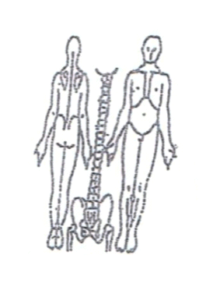 **Working Diagnosis:** Acute neck and shoulder painful obstructive syndrome due to cold – wind invasion and local QI stagnation (main SI channels involvement).

S: Acute pain at the back of the neck and over the shoulder area, 3-4 on the pain scale (1-10). Bad sleep, difficulty with dressing, with neck movement.

O:

Treatment (P) Acupuncture: local points following by the sedation of distal points. Main acute points ST38 (bilaterally). Vigorous manipulation to reduce pain and stiffness while the patient gently rotates the shoulders. (L,R), UB58 (L.R), SI9 (L,R), SI11 (L,R), SI 12 (L,R), SI13 (L,R), TW14 (L,R), TW13 (L,R), GB21 (L,R), L42 (L,R), H7 for nervousness and pain decrease.

(A) Acupuncture 1 hour due to protocol

**Date:__ ______________**

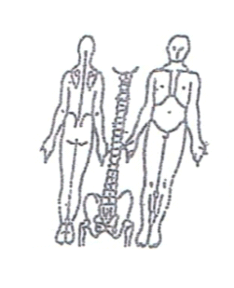**Working Diagnosis:**

S: Pain and difficulties dressing, taking the things in hands. No lifting, difficulties with movement and daily activities. Sleeping disturbances due to pain.

O:

Treatment (P) Acupuncture with Moxibustion – 1 hour due to protocol.

(A)

**Date:___**

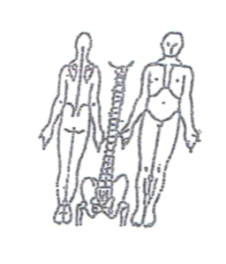**Working Diagnosis:**

S: Pain 1-2. ROM. Still having difficulties with twisting arms backward. Left is worse that right. Neck movement . Pain at the neck area. Sleeping N.

O:

Treatment (P) Acupuncture 1 hour with tens units for 30 min daily.

(A)

**Date:__**

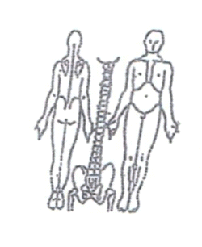

**Working Diagnosis:**

S: Patient feeling much better, more energized. Sleep N. N daily activities. ROM at the neck and shoulders area. Still have difficulties with left arm movement backward, recommended exercises.

O:

Treatment (P) Acupuncture with sedation of local points specifically SI channels.

Continue use tens unit 30 min daily.

(A)